Counter Strike: Global Offensive
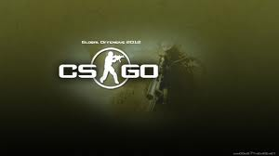
Can we forget how unforgiving Counter-Strike can be. Valve's outwardly competitive online shooter truly rewards the skilled and stomps all over the newcomers. There are no COD-style kill streaks, no artillery barrages to call in or packs of dogs to let loose. It's you, your guns, a few grenade types and your ability to show some cojones. Map knowledge, teamwork and planning are the only things that matter.
With Global Offensive (or GO), the next version of Counter-Strike, Valve isn't trying to completely reinvent the franchise. This isn't Counter-Strike 2, it's more like a step-up to the franchise. Terrorists still fight Counter-Terrorists in round-based combat. You still plant bombs on Dust and rescue hostages on Office. Some maps, like Dust and Aztec, received updates while others, like Dust 2, are largely unchanged. Though the changes aren't wild, franchise fans will find a few new interesting additions to the formula that may very well turn out to be series staples moving forward.
. Valve built an ELO-based ranking system into GO to determine your skill level, so ideally you're set up with players around your level of skill. Bots of appropriate difficulty settings will also be added in if a full game of live players can't be put together. If the idea of a five on five match sounds too limiting, PC players will be able to set up custom matches that Valve assures will provide the same degree of flexibility as is available in Counter-Strike: Source. Console players will not have the option to set up servers, however.
Once you do get a match up and running, the gameplay may be seem simple at first, but there's quite a bit of depth. Depending on the map the Terrorists either need to plant bombs or hold hostages, and the Counter-Terrorists need to stop them from planting and detonating bombs or rescue hostages. Before any of the fighting starts, you need to buy weapons by drawing on a personal pool of accumulated funds. Weapons include pistols, rifles, SMG and sniper rifles, as well as specialty items like flashbangs, high explosive grenades and smoke grenades. In the in-development build I played body armor is automatically purchased at a round's beginning, though Valve says when GO's done in 2012 the armor will be a separate purchase. In an interesting twist, defusal kits that let Counter-Terrorists quickly disarm bombs are no longer purchaseable. Instead they're randomly assigned to two teammates at a round's beginning.
Armor and defusal kit changes are important because you don't have infinite money in Counter-Strike. Kills and victories in each round earn you more funds, but you start off poor in GO's Competitive mode. The first round is typically only pistols, and if your team keeps losing don't expect to be running around with a one-shot kill AWP sniper rifle any time soon. Weapons need to be earned through skilled play, which makes acquiring them all the more rewarding. Alternatively, you can scoop weapons up off the ground from dead teammates and opponents, and in either case, if you die you'll have to purchase everything all over again. If you're new to Counter-Strike or don't want to have to deal with amassing a small fortune to buy your favorite gear, the Casual mode will be a good thing to try out where you'll get plenty of money each round to buy whatever you wish.
Games of Counter-Strike have no respawns, so if you die, you have to spectate the rest of the match. It can generate big drama when one team is down to a single player and the other has three or more (as well as barbed comments when the full team is revived at the next round's start). Considering how fragile every player is, it's entirely possible for one to defeat three. It comes down to accuracy, smart positioning and maybe a little bit of luck. If you want to pull off a comeback victory, you have to learn how to shoot properly.
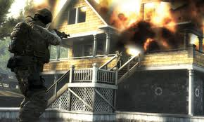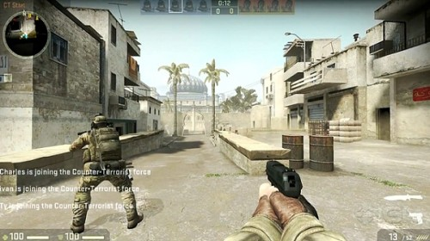
Another addition, the Zeus stun gun, is meant to be a tool of humiliation rather than something reliable. Valve considers it to be a joke weapon at this point. It's more expensive to buy than even the Molotov, carries only one charge, and needs to be fired at ultra-close range to hit. Though it seemed somewhat impractical given most are using deadly long-range weapons, I'm very interested to see if pro players may be able to come up with a more effective application for it. Many Counter-Strike favorites return like the AK-47, AWP, Desert Eagle and FAMASb, and other new weapons have been included as well that fill out the assault rifle and SMG categories. There's definitely a lot here to pick from, but the question of whether it'll all be useful remains, something Valve is looking to find out for sure in the beta.
If you've never played Counter-Strike obviously none of this means much, but it does result in a more balanced feel to the map even after only a few play sessions. Even small changes can have big effects, and the added staircase, as insignificant as it may sound to a newcomer, should ensure many a round is played on Dust once GO is ready for launch this year.Whether you're stricken with terror as a Molotov soars out of nowhere and explodes at your feet match or the last surviving Terrorist camping over a live bomb with four CTs on the way, Counter-Strike: Global Offensive is very familiar and still a lot of fun. Techahoy recommends it to all CS lovers, it’s a collectors item for sure!!

